
Software Requirements Specification (SRS)

Car Rental Management System

Submitted by:
Fazal-e-Rabbi 04072414035
Samiullah Saleem 04072414027
Hafiz Mustafa Saleem 04072414005
Muneeb ur Rehman 04072414010

Submitted to: Dr. Umer Rashid

Department: Department of Computer Science
Institution: Quaid-i-Azam University

Date: May 2026

Table of Contents
- 1. Introduction
  - 1.1 Purpose
  - 1.2 Scope
  - 1.3 Product Perspective
  - 1.4 User Characteristics
  - 1.5 Literature Review
  - 1.6 Proposed Technologies
- 2. Requirements
  - 2.1 Functional Requirements
  - 2.2 Non-Functional Requirements
- 3. Use Cases and Flow of Processes
  - 3.1 Use Case 1: User Registration
  - 3.2 Use Case 2: Vehicle Booking
- 4. System Design & Data Modelling
  - 4.1 Entity Relationship Diagram (ERD)
  - 4.2 Database Schema
- 5. References

1. Introduction

1.1 Purpose
The primary objective of this Software Requirements Specification (SRS) is to establish a clear, concise, and comprehensive foundation for the development of the Car Rental Management System. This document details the functional and non-functional requirements essential for automating the rental process. It serves as a formal agreement between the developers and the stakeholders, ensuring that the system architecture meets the operational needs of modern vehicle rental services.

1.2 Scope
The Car Rental Management System is a centralized web platform designed to facilitate seamless interactions between car rental agencies and customers.
- Customer Module: Includes registration, real-time vehicle discovery using advanced filters (make, model, price), booking management, and secure automated billing.
- Administrative Module: Provides high-level control over the vehicle fleet, user account verification, booking oversight, and analytical reporting on revenue and vehicle utilization.
- Security: Implements role-based access control (RBAC) to ensure data integrity and privacy across all user interactions.

1.3 Product Perspective
This system replaces manual, paper-based tracking with a robust digital infrastructure. It is designed as a standalone web application utilizing a three-tier architecture (Client, Server, Database). It leverages external APIs for location services and payment processing, ensuring a modular design that can scale with business growth.

1.4 User Characteristics
User Persona | Roles and Responsibilities
Guest User | Unauthenticated visitors. Restricted to viewing public car listings and site information. No booking privileges.
Registered Customer | Authenticated users. Capable of managing their profile, booking vehicles, providing feedback, and processing payments.
Admin / Operator | Privileged users. Responsible for maintaining car inventory, approving rental requests, and monitoring system health.

1.5 Literature Review / Similar Systems
Modern platforms like Uber and Careem have set a high benchmark for real-time logistics and user experience. This system draws inspiration from these platforms by focusing on low-latency availability checks and transparent pricing models. Unlike traditional manual systems, the proposed application minimizes human error in booking schedules and financial reporting.

1.6 Proposed Technologies
- Frontend: HTML5, CSS3 (Bootstrap), JavaScript.
- Backend: Node.js / PHP for server-side logic.
- Database: MySQL for structured relational data storage.
- APIs: Google Maps API for tracking and Stripe/PayPal for payments.

2. Requirements

2.1 Functional Requirements
ID | Title | Detailed Requirement Description
FR001 | Sign Up | The system shall allow users to register by providing a name, email, 11-digit phone number, and a secure password.
FR002 | Vehicle Search | Users must be able to search for cars based on specific parameters such as location, date range, and car category.
FR003 | Booking Logic | The system must automatically calculate rental costs based on duration and car type, and block the car for the selected period.
FR004 | Fleet Management | Admins must have the ability to add, update (availability/maintenance status), or remove vehicles from the active list.

2.2 Non-Functional Requirements
- Performance: Response time for search queries must be under 1.5 seconds.
- Scalability: The system architecture must support an increasing number of vehicles and users without performance degradation.
- Security: All sensitive data, including passwords and personal identification, must be encrypted using SHA-256 or equivalent.
- Availability: The system aims for 99.9% availability to ensure users can book vehicles at any time.

3. Use Cases and Flow of Processes
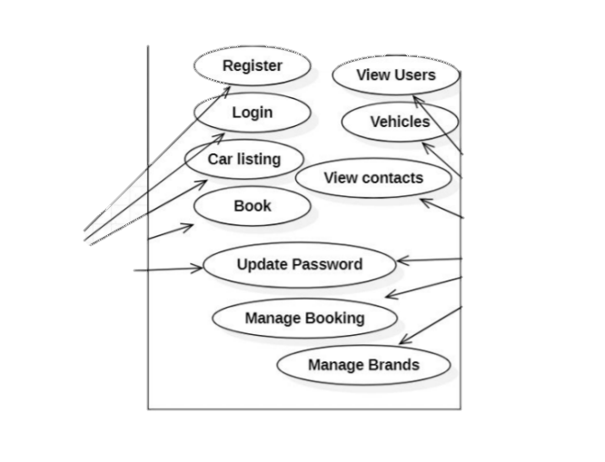

3.1 Use Case 1: Sign Up (UC001)
ID | UC001
Name | Sign Up
Actor(s) | Admin, Operator, Customer
Precondition | The user must not already have an active account with the provided email.
Basic Flow | 1. User selects 'Sign Up'.  2. User enters Name, Email, Password (8+ chars), and Phone (11 digits).  3. System validates inputs.  4. System stores user data and triggers a confirmation message.
Exceptions | Invalid email format; Password too short; Phone number not 11 digits.

4. System Design & Data Modelling

4.1 Entity Relationship Diagram (ERD)
The database is structured to maintain referential integrity. Primary entities include Users (linked to Bookings), Cars (linked to Bookings and Categories), and Payments (linked to Bookings).

4.2 Database Schema
The MySQL schema will consist of normalized tables to reduce redundancy. For example, the 'Cars' table will store static data (Model, Plate), while a separate 'Status' table will track real-time availability to optimize query performance.
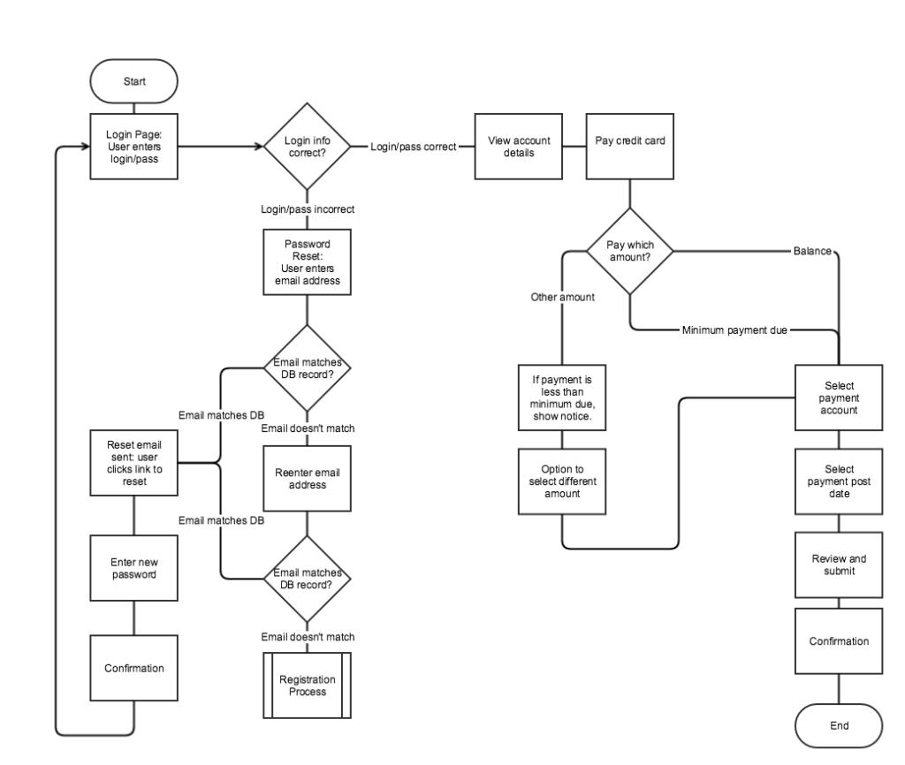

5. References
- IEEE Standard 830-1998 for Software Requirements Specifications.
- Official Documentation for Node.js and MySQL.
- Uber, Indrive

